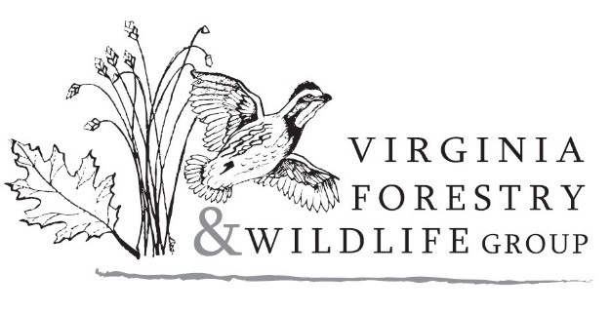
7202 Plank Road ∙ Afton, Virginia ∙ 22920 ∙ www.vaforestwild.com

Employment - Position Description

Virginia Forestry and Wildlife Group, a for-profit, natural resource management and consulting company based in Albemarle County, Virginia seeks to fill a full-time position within the company under the following parameters:

Title
Natural Resource Manager

Starting Date
Immediate

Type
Full-time/Salaried

Salary
Based on experience

Position Description
The Natural Resource Manager will oversee the implementation of natural resource management activities including but not limited to: prescribed fire, forest management, mapping, invasive species control, native meadow establishment and maintenance, tree/shrub planting, field surveys and assessments, and biodiversity restoration work. This is a leadership position and the Manager will be responsible for organizing work schedules and overseeing our field technicians. Excellent communication with company principals, staff and clients (private landowners, public agencies and non-profit organizations) is an important part of the position. The Manager should be certified or experienced in applying herbicides and conducting prescribed fire management, developing burn plans and overseeing their implementation. Other responsibilities include equipment maintenance and record keeping. Forest management background and a working knowledge of ARC-GIS are desirable.

